Edward Harding

[Email address]

Abstract

[Draw your reader in with an engaging abstract. It is typically a short summary of the document.   
When you’re ready to add your content, just click here and start typing.]

[Document title]

[Document subtitle]

Contents

Analysis 1

The problem background 1

Research into Accounting 1

The current system 1

Clarification of The End User 1

User requirements 1

Design 1

Why I chose to do an Object-Oriented Project 1

Class Diagram and Objects Used 1

Technical Solution 1

Project Layout 1

Client 1

Model 1

Server 2

Database 2

Why I chose to use Naked Objects Framework 2

The Advantages of LINQ 3

Functionality 3

Auditing 3

Testing 7

Evaluation 8

References 8

LINQ 8

# Analysis

## The problem background

Utopia Handmade and Vintage is a retail and clothing company. It is run by my brother Mr. T. Harding and his partner. The business is quite small and they tend to make most of their sales through online third-party websites such as etsy.com and also at stalls at multiple different music festivals. As the business is starting to grow and the company is transitioning from something more of a hobby over to an actual business, my brother has come to the realization that taxes and bookkeeping are legal responsibilities which will become very prevalent in his future. A lot of small business owners tend to use Microsoft Excel or bookkeeping software which can be bought online such as ‘Quickbooks’ and ‘Sage’ however I intend to make a program which can be used (most likely by him) to help assist and record the bookkeeping for the company.

As I personally had a very limited understanding of bookkeeping and accounting I decided that step one would be to do some basic preliminary research into this field. I came to the understanding that double entry bookkeeping is the standard method used in the modern world. Some other things I noted is the need and usefulness of balance sheets and profit and loss statements.

The second step I decided to take was to arrange a meeting with my brother as he would be the end user of the product I intend to build. The two things I was hoping to address with him were his current options for bookkeeping software which he could purchase and use, and the requirements he would need in a bookkeeping software for his business. After some quick research we concluded that although excel was the most cost-efficient option not only did my brother not know anything about using it but it also only allowed cashbook accounting where as he was looking for a double entry bookkeeping system. The other requirements he noted will be mentioned further on.

To conclude I decided that I would start of by creating a very standard double entry bookkeeping system as this would act as a good foundation to add improvements to and tailor it towards the end users more specific requirements. This also helps as it allows for me to make sure the basics are all up and running before getting into a greater level of depth and detail.

### Research into Accounting

I came to the realization that I will need to learn a substantial amount more about accounting and bookkeeping to be able to fully take on and produce a suitable product for my client. To do this I have decided to use a very well acclaimed textbook which is used by most schools and colleges in the UK to teach accounting. It is called “Business Accounting 1” by Frank Woods and Alan Sangster. The book starts from the very basics of accounting and provides multiple practice questions and examples which I will be able to use in the testing and development of my project. I am hoping to progress my program as I progress through the textbook so I can develop the program hand in hand with my learning of the subject. This is how I plan to create the foundation for my program as stated earlier.

### The current system

The company is currently quite small as I stated earlier and is therefore under the minimum tax bracket. This means that currently they do not have any system in place for bookkeeping as there has been no need for it so far.

### Clarification of The End User

Although my client is Utopia Handmade and Vintage I would say that Mr. T Harding will be my sole end user for the system as he is one of the owner’s and the most likely out of the two to be doing the bookkeeping. He will be my first point of contact for information on what he will require from me. Therefore, the system will be catered towards his requirements and he will also be the person I get to test the program once it is in its later stages and past the book level testing.

### User requirements

1. The program should be able to perform the basic functions of a double entry bookkeeping system, this includes but is not limited to:

* Allowing the user to create multiple different accounts.
* Allow the user to add sub accounts.
* Allow the user to record transactions between the accounts.
* Use these transactions to form a balance sheet.
* Use transactions to make up a profit and loss statement for a requested time period.
* The program should also have the ability to audit user’s actions.

1. The system must be easy to use, simple to understand and navigate, and display data and information in a way which is tidy, efficient and easy to understand.
2. The system will NOT require any authentication process as It will be a locally run program therefore it will only be accessed from the clients own computing device.
3. The client would like the system to be as aesthetically pleasing as possible; as it will be used for long hours therefore it should not be dull.

I would like to expand on Auditing which was mentioned in point 1. Auditing is very much an important part of an accounting system, it does not add value to the actual value to the arithmetical function of the program, but every accounting system should 100% have auditing functionality for legality reasons. Both Sage and Quickbooks do have an audit trail (excel has some ability to record user actions but it is not up to standard).

Of course, the example I mentioned earlier such as Quickbooks and Sage can do all of these things and more however I believe that as Mr. Harding the end user is new to bookkeeping it would in fact be more beneficial to keep the accounting side to the simplest level possible. One other important thing is that my code will all be free and open source (being shared via GitHub) this allows for other users to further extend to its functionality and add complexity to it if needs be.

# Design

Add more class diagrams showing relations etc. not just inheritance.

Remove mentioning things like autocomplete.

## Why I chose to do an Object-Oriented Project

The greatest reason I had for choosing object oriented programming was due to the ability to create user defined objects to be used in my program. After I decided on my project idea I sat down and thought about some of the basic functionality it would need to do and the easiest way to implement it. I had already had some experience with OOP and after looking at the basics of an accounting system I noticed that there were lots of clear objects which could be created. The ability to create your own object set properties and give functionality to the objects really stood out as a necessity to me in designing my project.

A more trivial reason for my decision to go with OOP was just for organisation of the code in visual studio. OOP allows for your code to be split up over multiple segments which allows for easy navigation and organisation of your program.

Another big selling point to use polymorphism is inheritance, having the ability to create sub/super classes of your use defined objects is incredibly useful to reduce the repetition of code and functionality, which in turn reduces the likelihood of errors and usually makes them easier to fix if they effect one part of a class hierarchy rather than finding an error in a part of code in an object which is in other objects and then having to individually fix them all.

**System Design**

The base user interface will be created by Naked Objects Framework, this includes Action bars, menu buttons etc. However I will make a few changes to the base design such as changing object colours to help provide standardisation between objects, this will help the user distinguish between types when multiple objects are being displayed on the same page. Below I will explain the main components of my project and what I want them to achieve in terms of functionality, usability, display and restrictions. Actions on instances of objects can be accessed via the action tab at the top of the UI which is on all instances of objects. The parameters for specific objects are explained in the following part of the design section, here I will be discussing more about there layout and integration into the user interface and methods they may have.

**Login / Authentication**

The login system will be done using Auth0. Auth0 is a third-party login / identity authenticating software which can be integrated into a program which has access to the internet. Auth0 will allow for people to login into my project using a google account, this will then provide me with the data I need for auditing. I feel that using Auth0 is the right direction as it will reduce the time I need to spend on the login side of my system which isn’t fundamental to the overall functionality which I wish to achieve from this project, however it is needed for Auditing capabilities.

**Home Page**

The Home Page will be the first page displayed to the user after they have Logged in. It won’t have any specific functionality, it will just be used to separate the two sides of the project, that being the double entry bookkeeping side and the Auditing / Administration side.

**Accounts**

*Home Page => Main Menu => Accounts*

Accounts will be accessible from the Main Menu via an Accounts option which should contain an “All accounts” option or by using the “Find Account by Name” option. Along with transactions; Accounts are the base of a bookkeeping system as they are effectively the conduits for which money is spent and earned through. There are no methods / actions I need on accounts as they are primarily used by other aspects of the project as they are mainly used for holding data. The Accounts Menu will also need an action for creating an Account. Accounts should contain a name, a type of account (capital, assets, liabilities), balance (based on transactions) and a list of credit and debit transactions involving that account.

**Transactions**

*Home Page => Main Menu => Transactions*

The main menu should contain a Transactions option which will contain an “All Transactions” option which will display all transactions in date order, displaying the newest at the top. A create new transaction option should also be available, this should implement both a drag and drop and auto fill features for filling out the Accounts field. There should also be a find Transaction by date option. The Transactions themselves should contain an action called “Show History” which is part of the auditing system. This action should show a list of previous versions of that transaction (if it has any previous versions). This is useful because say a Transaction has been updated and you are looking at it in the Audit Record menu you will be able to click that transaction to go to and then perform the “show history” action to see the previous versions. Transactions should show the date of transaction the debit and credit accounts, the amount and the name given to it by the user.

**Balance Sheet**

*Home Page => Main Menu => Balance Sheets*

Balance Sheets will contain a method to view all balance sheets and a method to create new balance sheets. The balance sheet will evaluate the transactions and accounts to assert that all movements of money have been accounted for, this is done by checking that the sum of assets and capital minus liabilities equals zero. Instances of balance sheets should display all accounts of type asset followed by their balance total and then the same for Liability accounts and Capital accounts. Right at the end there should be the total for Assets Minus Liabilities and Capital and then the balance for the whole sheet which should always equal 0.

**Profit and Loss**

*Home Page => Main Menu => Profit and Loss*

Profit and Loss will contain a method to view all profit and loss statements and a method for creating a new profit and loss statement. The profit and loss statement will need calculate the profit made from sales between two dates (entered by the user when created). It will do this by adding up the price the stock was sold at and subtracting the price the stock was bought at by the company. The information for these values on individual items will be held by a sales object which will act similarly to transactions (explained further on in this section). No actions should be needed on Profit and Loss statements as they are basically reports. Profit and Loss statements should show the start and end date for the statement and the gross profit over that time.

**Auditing**

*Home Page => Audit Menu*

As mentioned before the Auditing system will need to have user login details to work as the point in auditing is that you know the what happened, who did it and when it happened (the action, the user and the date time). Unlike the other parts of the project I want Auditing to have its own menu accessible from the Home Page and not be a part of the Main Menu. This is because Auditing is more of an administration section of my project rather than actual functionality to do with double entry book keeping. Inside the Audit Menu I will create Audit ‘reports’ such as “List all Audit Records” and then some specified ones such as “List all Audit Records for Persisted Objects”, and more. This is just for usability purposes so that the user can access specific Audit Records easier than having to search through all of them.

## Class Diagram and Objects Used

Overall Class Diagram.

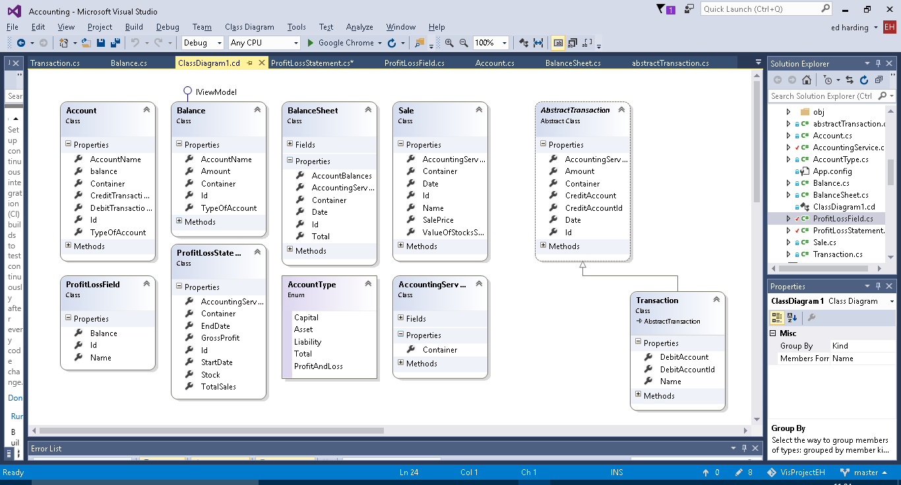Account

The account class is – as it is named – meant to represent an account in a running business. Every business has a list of different accounts which are used to record the movement of money and value of objects owned by the company. For example, a small retail company may have an account for the current cash held by them in store.

The account contains a collection of transactions and a calculated balance from these transactions. As this balance is used in the balance sheets and balance sheets can be made for past dates a function to calculate the balance at a specific date is needed. For both of the above a function to calculate a total balance is needed therefore a function can be made to do this to reduce repetition.

Balance

The Balance class doesn’t really have a business application behind it, it was just necessary to have for functionality purposes to be used as to retrieve and format the account data into the balance sheet.

Explain why I view model used.

Balance Sheet

As it is named the balance sheet object is made to create a balance sheet and calculate the balances of all the accounts and make sure that the capital equals the company assets minus liabilities.

A title builder method is implemented this is so that an apt title can be created automatically for the user using the date for which the balance sheet is for. This allows for them to be ordered in the user interface by date for user convenience.

Abstract transaction

An Abstract super class for transactions. Which will have more sub-classes.

Contains an auto complete method for the account to be credited for user convenience.

Transaction

The most common type of transaction made in a double entry bookkeeping system. It debits and credits individual accounts as it should. As you can see from the class diagram it is a sub class of Abstract Transaction.

Transaction also contains a title builder which creates a title consisting of the inputted transaction name and the date of which the transaction occurred, again this is just for user convenience and for data recording purposes. As Transaction is a sub class of abstract transaction it auto inherits the auto complete method for the account to be credited. However, it also contains an additional auto complete for the account to be debited (works the same as the credit one).

Account Type

The accounts in a double entry book keeping system fall into three categories capital, assets and liabilities. I need a way to represent them, so that total balances of each category can be calculated so that the balance can be checked as already mentioned in the Balance Sheet. The easiest way to do this was to create an enum.

Accounting Services

Accounting services doesn’t really represent anything specific in business terms it just adds functions which are useful to multiple different objects and to the user in the user interface, such as being able to add new instances of objects like Account and transactions. It also contains methods for the user such as listing all the accounts, transactions, balance sheets etc.

**Sale**

Is used in the profit and loss side of the program. Represents a sale of goods to a customer, and records the profit or loss made from that sale.

Sale also has a Title builder method which like transaction creates a title from the date of the sale and the name given to the sale.

**Sales Account**

Is used to create the fields used in the profit and loss statement, those being the total value of the stock and the total value for sales made.

Needs renaming to ProfitLossField.

**Profit Loss Statement**

As the name suggests this class creates a profit and loss statement for a given time frame. It does this by getting the Sales (from Sale) made in that time frame and the value of the stock (at the latest point of the time frame) and then calculating the amount of stock sold and for what total price it was all sold at.

**Additional Class Diagrams**

Below is the class diagram which displays the object associations for the main part of the prgram(that being the transaction and balance sheet functionality) the objects are described in the previous section.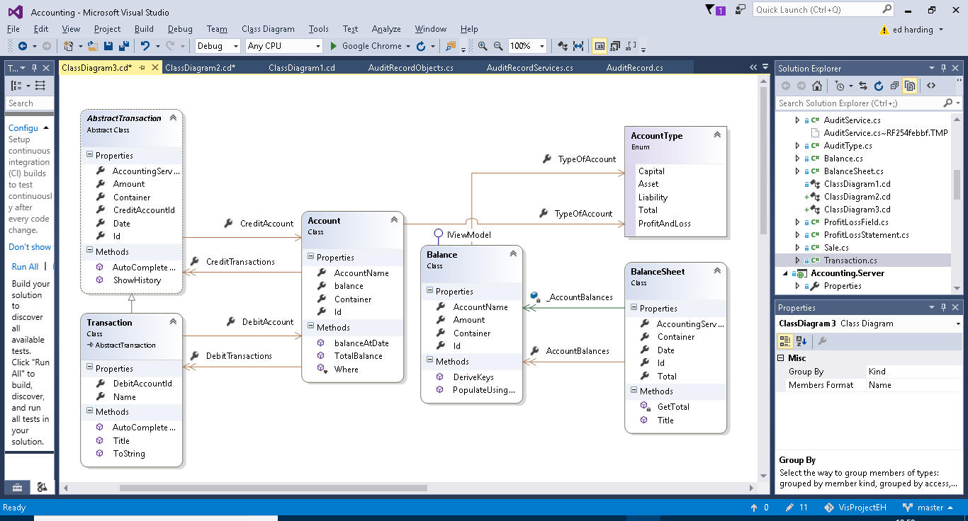

Below is the class diagram for the classes related to the profit and loss statement functionality of the program.

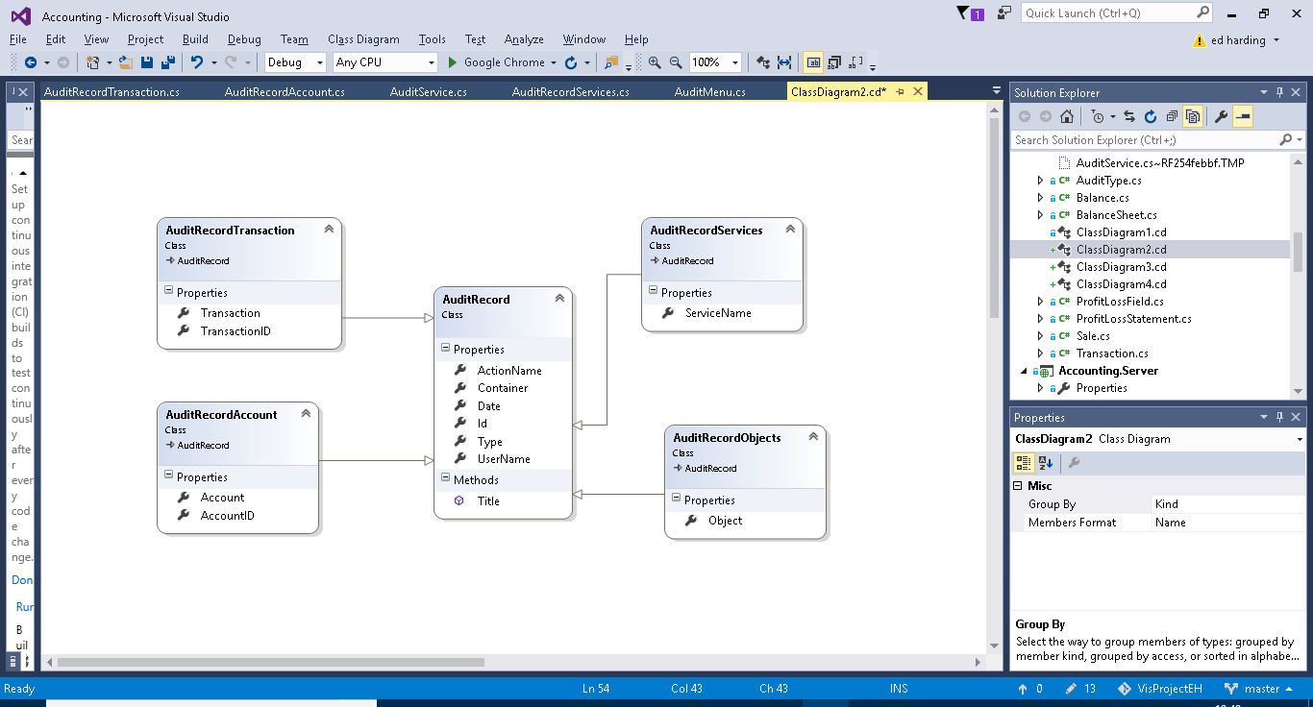

# Technical Solution

One point you have missed about LINQ (though you hint at it indirectly) is that all operations are conducted in terms of the objects’ types and properties, not in terms of the database (e.g. table and column names). If you rename an object property, the LINQ query will be changed. Not true of SQL. This concept is known as ‘type safety’.

Iterations moved to “Appenix” word document

## Project Layout

Explain the project layout e.g. why there is 4 projects in the solution, what they do etc.

The Solution consists of four separate projects. The Client, Model, Server and Database projects. These projects are required by the NOF…….should we mention the template project? (yes, should mention we used it) Below is a breakdown of the projects into more detail.

### Client

Provides single page application pre-configured to connect to Server. Not My code. Using the generic interface, (can change colours etc.), there is scope for further customisation, but I didn’t do any.

Generic UI, show it supports drag and drop as an example. Show some customisation.

### Model

For objects / classes and services. (where objects from the design section are coded, show AN example). Auditing is also in there. Model is where I wrote most of my code.

Objects and services/repositories.

Show Programming techniques (here’s my code, here’s what it’s doing in the UI) Show examples of actions. (show collections etc. lots of examples); Show validation (robustness)(add validation); User-friendliness (auto Complete); Attributes(using [] hiding objects changing layout etc. etc.) LINQ & repositories.

Specifics (IViewModel) (Put Auditing section in here).

#### Intro

#### Functionality

##### Objects

##### Usability

##### Robustness

#### Auditing

#### Use of an IViewModel

### Server

RESTFUL API, local host, browser display etc.

All tests were run from this local machine the plan is that eventually the Server will be deployed as a webserver.

Naked Objects run settings /configure. All I really did was this.

### Database

Entity Framework, how we are mapping our objects to the database. Objects being persisted on a relational database (Microsoft sql server). Put the Entity framework paragraph into here. Show AN example “here’s the object”, “here’s the table” (show table from database). Also include the SQL reports we wrote.

What DB context does (persisting objects)

What DB initializer does (seeding data)

#### Entity Framework

Entity Framework is an integral part of the project as it acts almost like a translator between the business-based objects I have coded and the SQL server database. Entity framework has the ability to format and map user made objects to a database by creating an Entity Data Model from the objects it does this by using a technique called object relational mapping. ORM is a method for converting data of incompatible types into a virtual object database. Entity Framework is a Microsoft product therefore combined with Microsoft Visual Studio there should be little bugs in this process. This therefore reduces a whole work load for the developer. It also allows the developer to perform LINQ queries in C# on the database. This is extremely useful when creating searching methods and such.

#### DB context

#### Db Initializer

## Why I chose to use Naked Objects Framework

I chose to use Naked Objects Framework for multiple reasons. The biggest advantage for using it is its UI. The client side of NOF is brilliant for database orientated projects as the UI will automatically display objects in a tabulated way similar to how it would look in a database. It also separates object methods and adds them to the actions button on the UI. This is all customisable from inside the objects. The UI’s colour and layout can all be customized, this includes individual objects and everything.

NOF also contains the ability to set up user profiles using Auth0, this can be done via a developer-built profile system or using something like google accounts this became useful in auditing.

Another advantage I found when researching NOF was that it provides ‘hooks’ which can be used for auditing. A hook will pick up certain user actions and they allow for me to write code to determine what happens when they are picked up. This allowed for me to implement and auditing system. Using the hooks and the NOF Auth0 user profile system I was able to create an Audit service which would use the ‘hooks’ to audit the user by saving information about the user’s profile and the action they performed into an Audit Record object class.

Allowed me to focus more on building a more complex object model / solution.

## The Advantages of LINQ

LINQ is a uniform query syntax which is integrated into C#. It is very similar to SQL in the way that it is used to save and retrieve data from a database. The significance of LINQ is that because it is integrated into C# it can easily interact with databases created from within my project.

There are many advantages to using LINQ over SQL. Structured Query Language (SQL) has been around since 1974 and in this whole time it has never truly been revamped it has just been extended. As you can probably guess this has caused it to become very clunky in comparison to today’s languages. LINQ is a lot more compact compared to SQL, below is an example of a LINQ statement from the Account Services class.

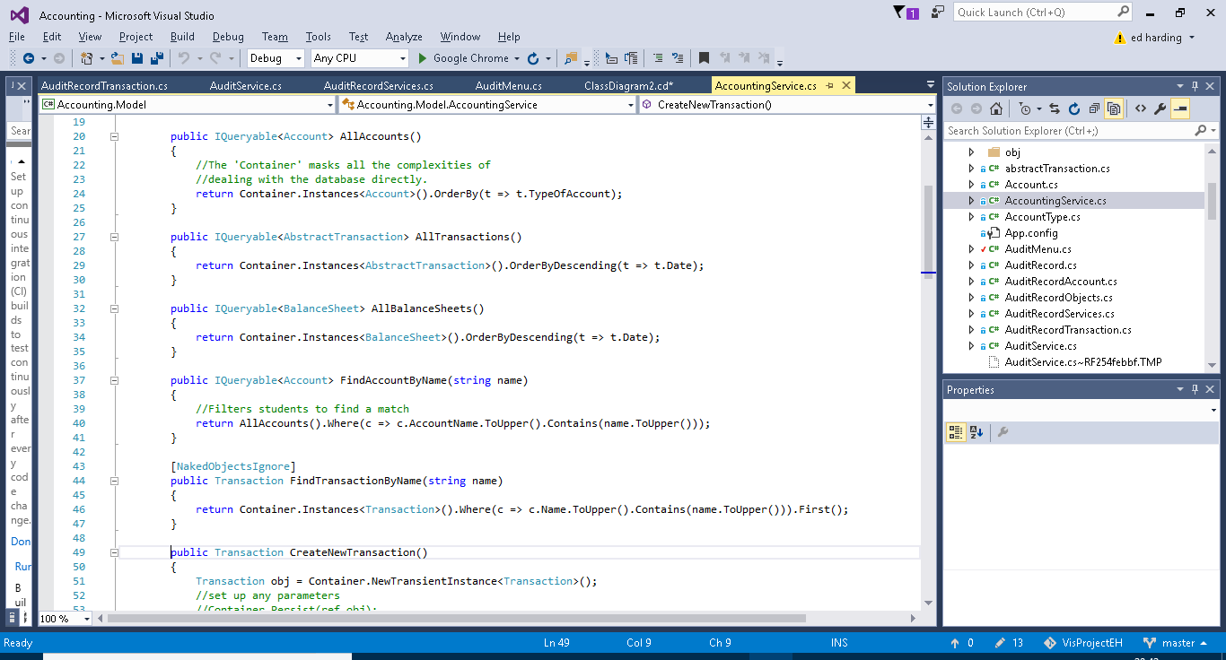

As you can see this is a lot more compact compared to the traditional SELECT FROM WHERE SQL statement which can get very bulky the more complicated the query gets. Another advantage of LINQ is that it is written in a way which is very similar to C# it uses the “.” syntax and C# and user made methods can be incorporated into the query. For general coding it is easier to stick to one form of coding rather than switching between two. *[Probably Needs More]*

A final point I would like to make about LINQ is that it is technically a form of functional programming. Functional programming is a relatively new programming paradigm which does not allow for any sequential command execution and instead uses functions made up of one single expression. LINQ achieves via the use of a lambda expression. Show and example.

## Functionality

### Auditing

Auditing is one of the more complex capabilities of my program. My auditing code can be split into 3 sections (I will go into more detail of each below). The AuditService which detects when actions have been perfomed by a user, the AuditRecord which is used to save information about the action and user and finally the AuditMenu which is the UI end of the audit capability, it is used to display the audit records to a user.

#### Audit Service

The Audit service constists of 4 methods each will be called under different circumstances.

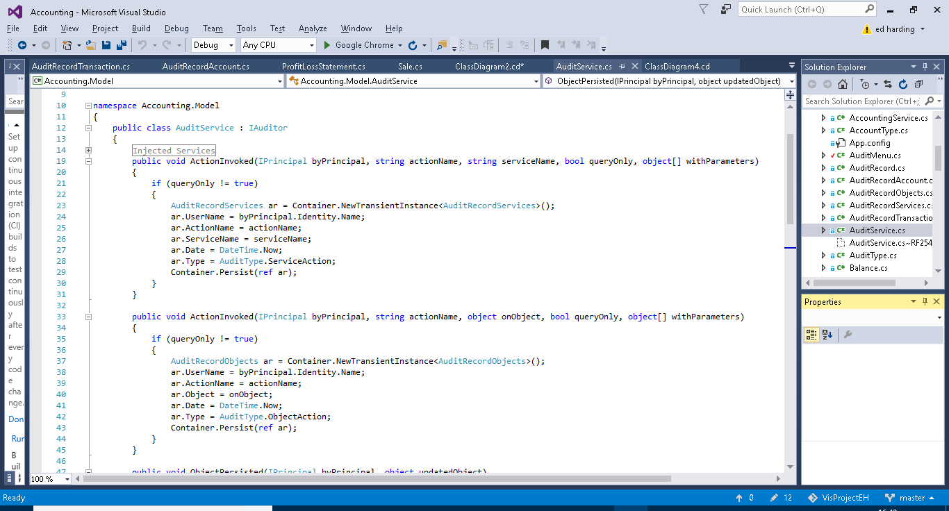

The first method (above) is called when a service action (e.g.) is executed by the user. The if statement checks to see if the action was a query only action, if it is nothing will happen as queries don’t necessarily need to be recorded as nothing critical is happening to the data. If the action isn’t a query action the method will create a new instance of AuditRecordService (AuditRecords are explained further on in this section). It then fills out the fields from AuditRecordService and persists the new instance. The username is obtained from the byPrincipal parameter. The username comes from the Auth0 log in system. AuditType is an enum I created for querying purposes you will be able to see this in use later on.



The second method is very similar to the first however it acts upon actions performed on objects (e.g.). Like the first method it checks whether the action is query only or not, it then creates a new instance of AuditRecordObjects, fills out the fields and persists the new instance.

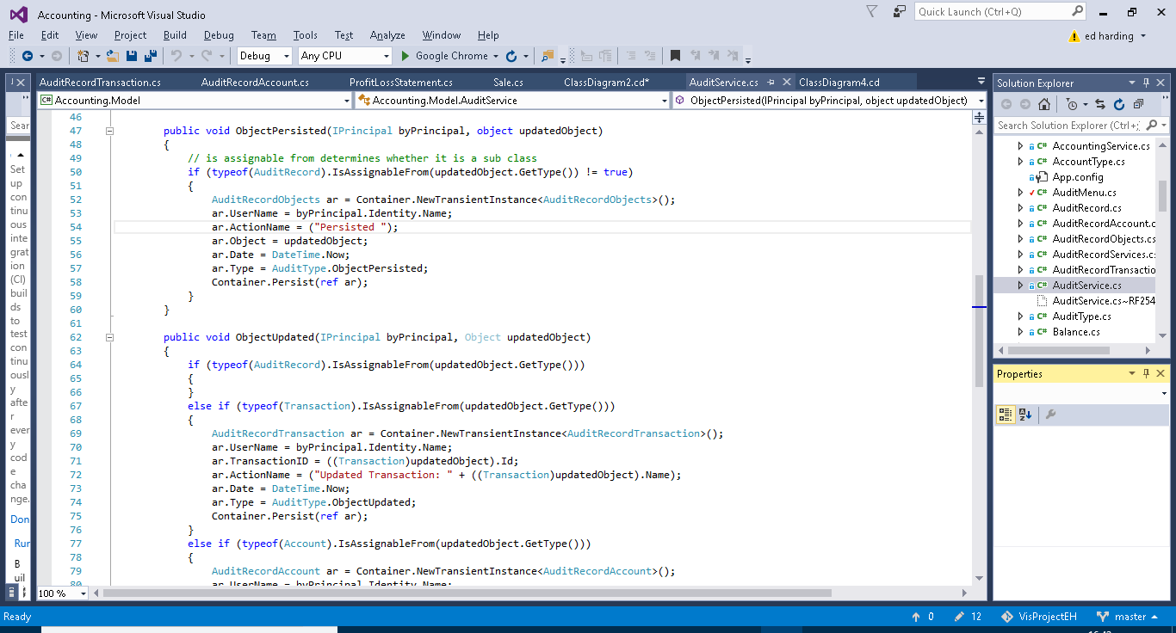

The third method is for auditing persisted objects. The first if statement is very important, its purpose is to assert whether or not the object which has been persisted is a sub class of AuditRecord (e.g. AuditRecordService), if it is then the method does nothing. This is important as without this if statement this method will be called whenever any AuditRecord sub class is peristed such as in the previous methods. As this method itself persists a subclass of AuditRecord it then will get stuck into a loop and a stack overflow error would occur. If the persisted object is not a sub class of Audit Record then the method will create, fill out and persist a new instance of AuditRecordObjects. The action name is not passed in through a parameter as in previous methods and is therefore declared as “persisted” by the method.



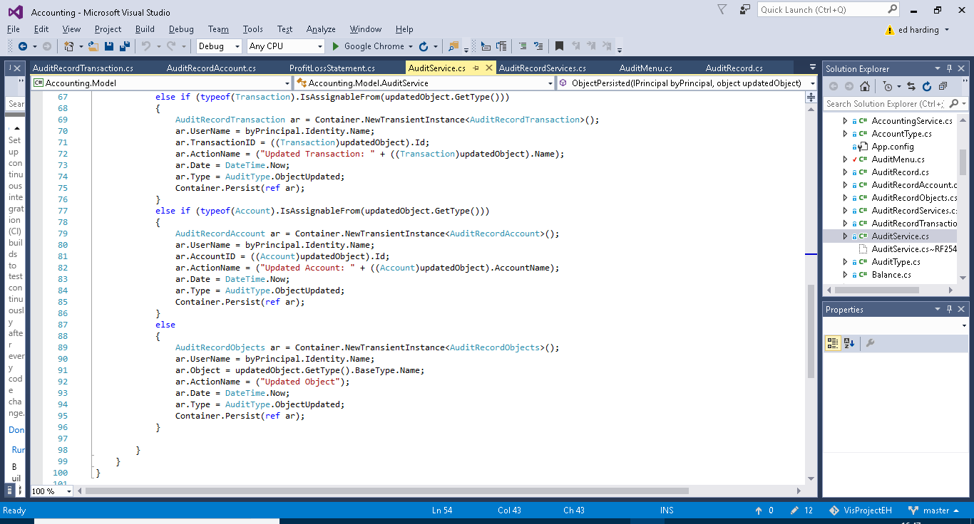

Similiarly to the previous method the first if case checks that the updated object isn’t a sub class of Audit Record, again this is to aoid stack overflow errors as described before. The next three if cases are to establish if the updated object is a transaction, account or other object. This is because transaction and account have their own subclasses of AuditRecord. As before a new instance of the required AuditRecord subclass will be created the fields initialised and then the instance will be persisted. The advantage of having Account and transaction records separate from one another and other objects is so that the name of the account or transaction can be added to the action name for userbility purposes and for querying advantages.

#### Audit Record

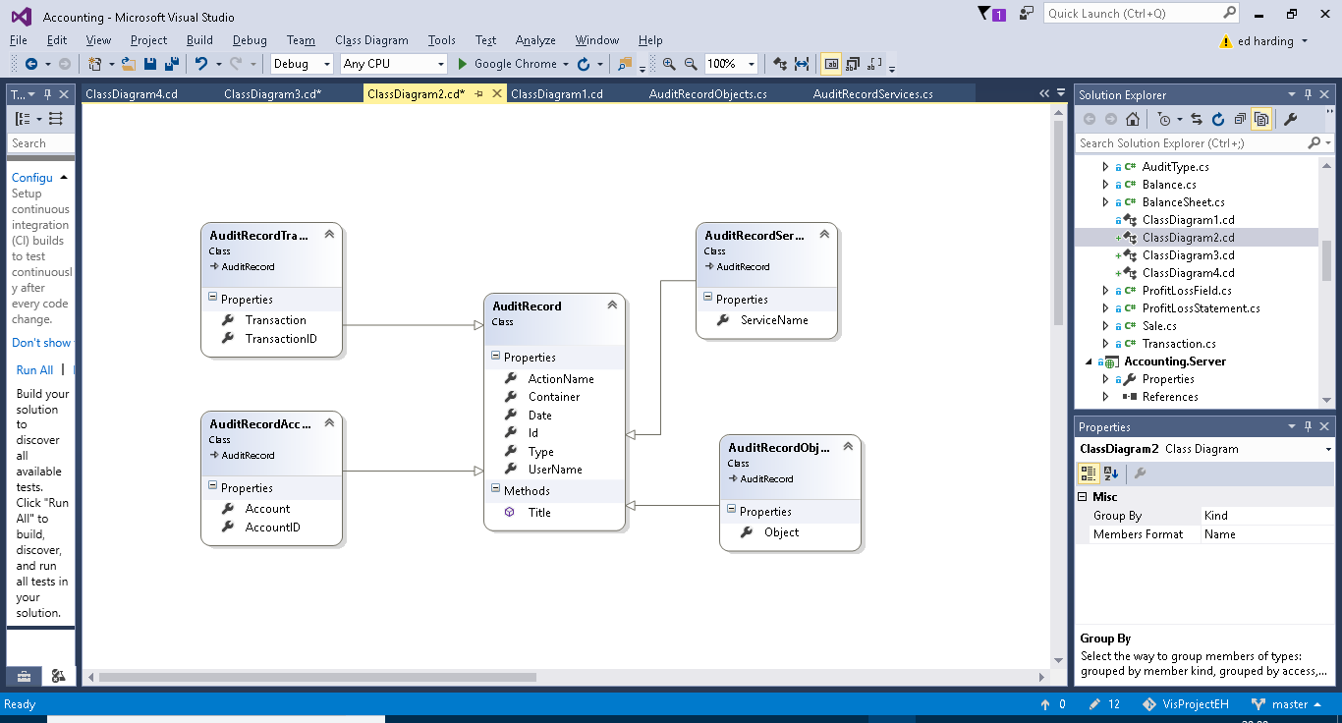

Above is a class diagram showing the four subclasses of account record. These were used in the methods in Audit Record (previous section).

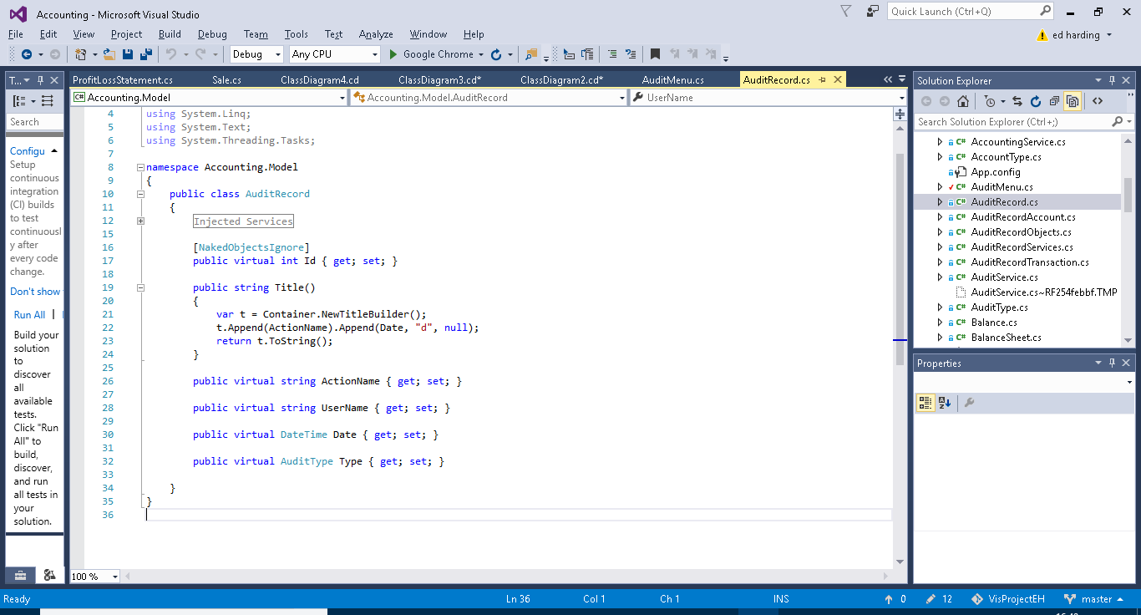

This is the super class Audit Record. It contains the Username ActionName and Date fields, very typical and useful information for someone auditing the system. The AuditType field is for querying purposes. And the Title Builder is for usability purposes i.e. making the name of each instance of AuditRecord more presentable and convenient for the user to find what they need as it combines the date and the action name. The subclasses each have one or two additional fields specific to themselves.

#### Audit Menu

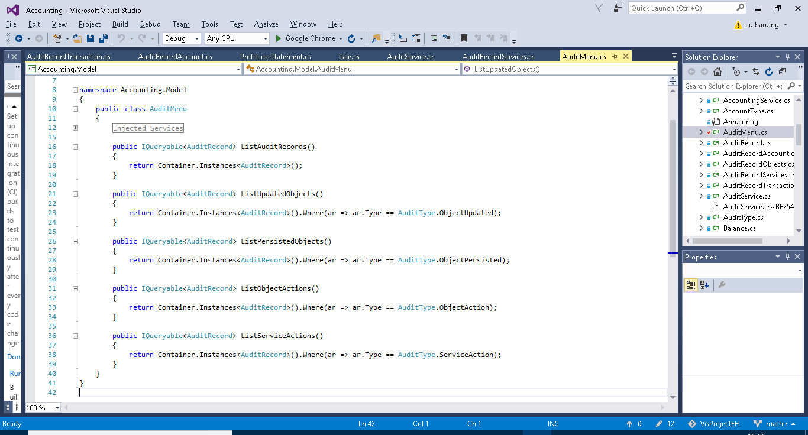

The audit menus sole purpose is to provide pre-built query methods on the entirety of saved AuditRecord. These methods just make it easier for the user to find what they want. The first method just outputs an entire list of all AuditRecord (this being all the instances of the subclasses of AuditRecord). The second method Lists all the instances of AuditRecord which contain information on Updated Objects. The third method Lists all the instances of AuditRecord which contain information on Persisted Objects. The fourth method lists all the instances of AuditRecord which contain information on executed object actions. The fourth method lists all the instances of AuditRecord which contain information on executed service actions.

# Testing

* Test Table and results, explain results especially if not expected result.
* Test/demonstration video, should start scripting soon, will help pick up on anything I need to fix or add to the program.

|  |  |  |  |
| --- | --- | --- | --- |
| Test | Input | Expected Outcome | Actual Outcome |
| Create and save an account. |  |  |  |
| Create and save a Transaction |  |  |  |
| Create a balance sheet. |  |  |  |
| Etc. |  |  |  |

# Evaluation

* Did it meet end user requirements.
* What I could do better/improve with more time.
* What it should have if it was a complete business level program.

# References

## LINQ

* <https://www.linqpad.net/WhyLINQBeatsSQL.aspx>
* <https://docs.microsoft.com/en-us/dotnet/csharp/programming-guide/concepts/linq/>
* <http://www.tutorialsteacher.com/linq/what-is-linq>